**Lab 7**

**This lab is worth 5% of your final AI4G grade.**

**Due End of Day Sunday February 23rd**

**How to Train your Artificially Intelligent Dragon via Backpropagation**

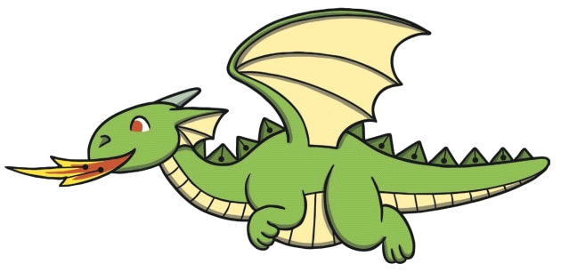

**To do:**

Follow the instructions in “Back Propagation Solution Walk Through.docx”.

Type your name here Daniel Carroll

Copy in screen shots in to this document to demonstrate completion of the following (something in the image should identify your own machine):

* The TensorFlow training showing the 15 predictions it makes at the end of the training process.

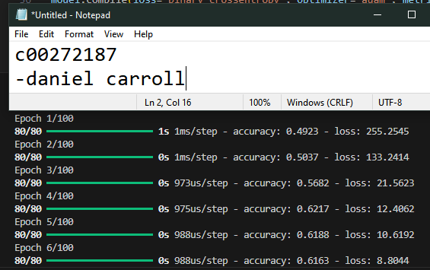

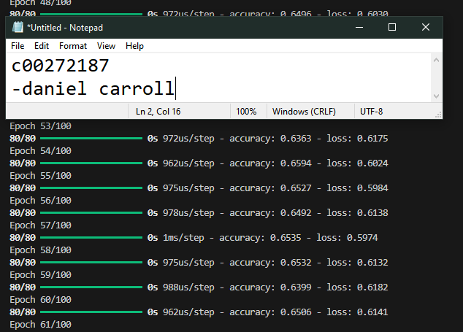

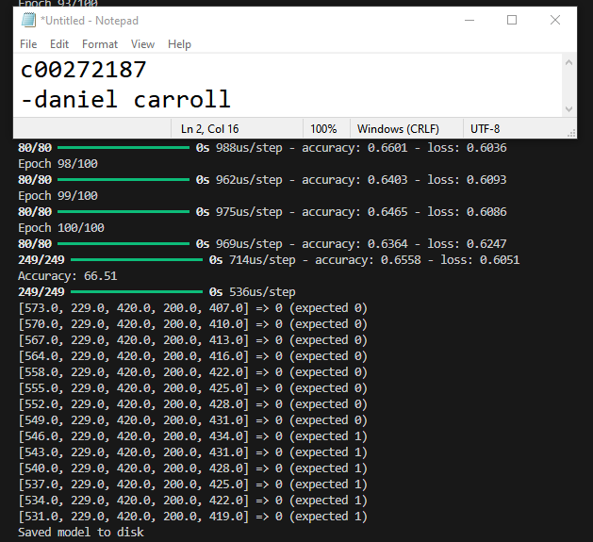

* Successful output from the execution of the “convert_flappy_model_weights_to_csv.py” script.

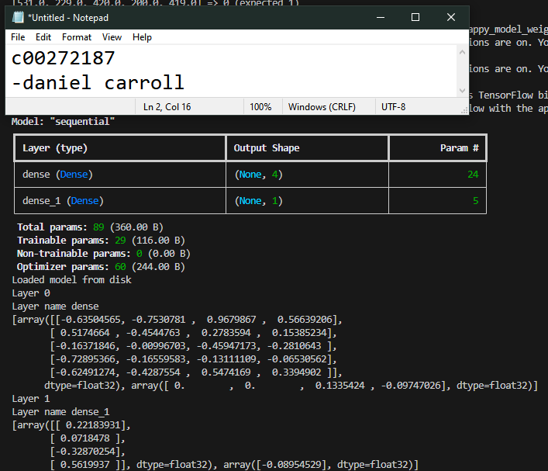

- flappy_tf_weights.csv

* The AI playing the game with the trained weights showing at least one bird with a fitness > 100.

